INTERNSHIP TASKS IN JAVA

TASK1:
FILE HANDLING UTILITY

Output:

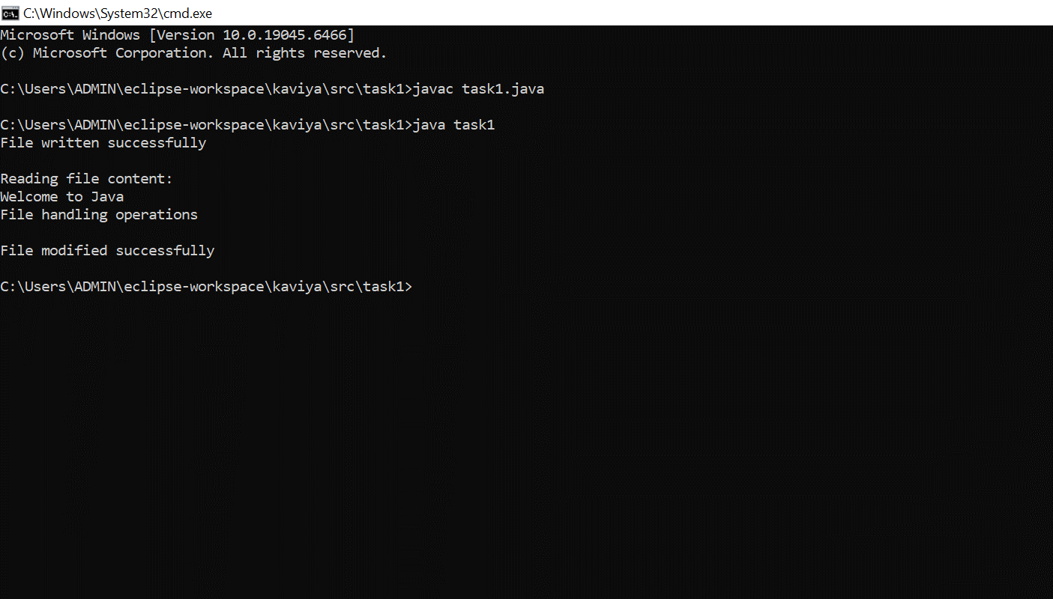

TASK2:
REST API CLIENT

Output:

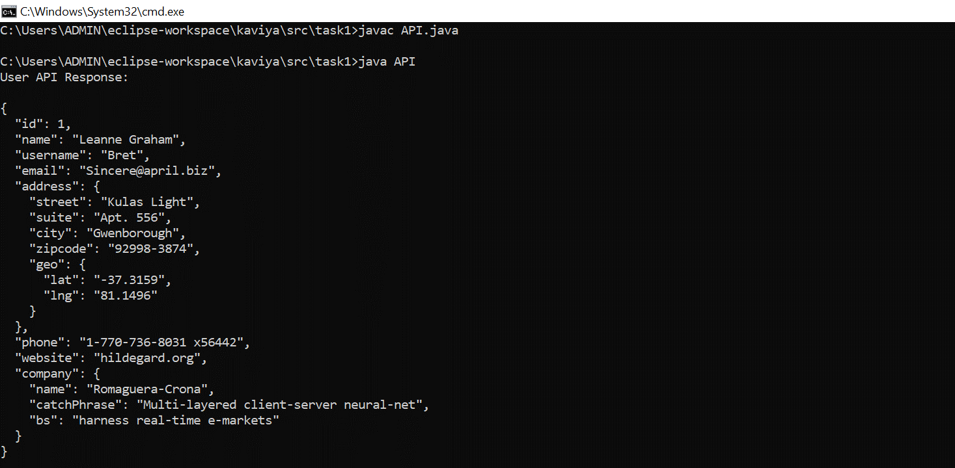

TASK3:
MULTITHREADED CHAT APPLICATION

Output:

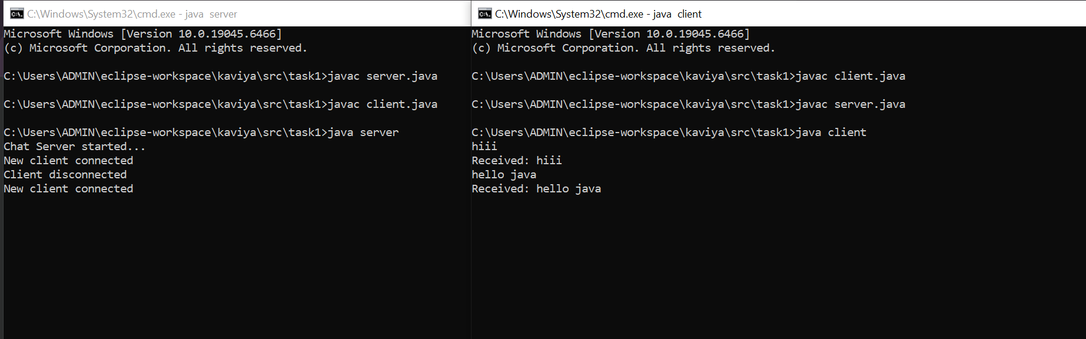

TASK4:
AI-BASED RECOMMENDATION SYSTEM

Output:

